**Leader Overview**

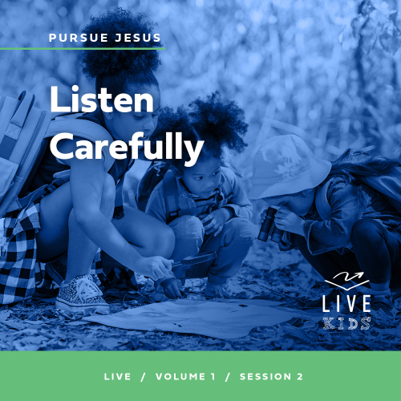

**Volume Overview**

**Pursue Jesus**

*Jesus’ offer is remarkably clear: If we look for Jesus, we’ll find Him. He’s not hiding from us, but closely connecting with Him does take us being intentional. We’re called to follow Him, to pursue Him. In this volume, we’ll look at how individuals pursued Jesus through the challenges of their circumstances. Pursuing Jesus is not only a mental exercise for personal growth, but it also means living out our faith in tangible ways: showing up, listening carefully, receiving grace, and trusting Him.*

**Session Overview**

**Listen Carefully**

*In this session, kids will explore the journey of a man named Nicodemus—a Pharisee, or Jewish religious leader, who wanted to know more about Jesus. Nicodemus found opportunities to seek out Jesus and listen to Him. We can always take time to listen to Jesus, too.*

**Bible Lesson**

Nicodemus Seeks Jesus for Answers

[John 3:1–21](https://ref.ly/logosref/Bible.Jn3.1-21)

**Faith Fact**

I can always listen to Jesus.

**Faith Verse**

[Jeremiah 29:13](https://ref.ly/logosref/Bible.Je29.13) (NLT)

“If you look for me wholeheartedly, you will find me.”

**Preparing for the Session**

**Leader Preparation Time: 20–25 Minutes**

|  |
| --- |
| ***You Will Need***  ***Large Group***  *• Bible*  *• Worship songs (Song suggestions: “Shine a Light” by Kids on the Move; “Available” by Elevation Worship; “Fresh Chance” by River Valley Worship [lyric video])*  *• For groups not using a phone or tablet only, add:*  *• Projector or TV*  *• Laptop*  *•* ***Faith Fact Slide***  *•* ***Faith Verse Video*** *or* ***Slide***  *•* ***Bible Lesson Video***  *•* ***Teaching Point Slides 1–3***  *• Flashlight*  *• Optional: Leader’s baby picture*  ***Small Group***  *• Balloon(s), one per group*  *• Bibles for kids in the group to share*  *•* ***Small Group Faith Verse Review****, one set per team*  *• Cup, one per team*  *• Smartphone or timer*  *•* ***Small Group Activity Page****, one per kid*  *• Pencils or pens, one per kid*  *To access session content and videos from a computer, visit:* [***BibleEngagementProject.com/downloads***](https://bibleengagementproject.com/downloads) |
| ***Getting Ready***  ***Large Group***  *• Download videos and slides if needed.*  *• Select worship song(s) and have them ready to play.*  *• Read the Bible Lesson Scripture to prepare for Teaching Time.*  *• Order disappearing paper for Session 1.3 Teaching Time.*  ***Small Group***  *• Blow up the balloon(s). Don’t use helium.*  *• Print copies of the* ***Small Group Faith Verse Review****, one set per group.*  *• Place each set of slips in a cup, one set per team.*  *• Print copies of the* ***Small Group Activity Page****, one per kid.*  ***First time leading* Live *for Kids? Check out the*** [**Facilitator Guide**](https://0b769b0ed3569ef9d18b-f88d8272f61086866d50d048b43ef630.ssl.cf2.rackcdn.com/sites/biblengagementproject/Listen_Facilitator_Guide.pdf)**.** |

**Large Group**

**30 Minutes**

*See what’s needed at the beginning of the session.*

**Introduction**

I’m so glad you came today! I love reading the Bible and learning how to live like Jesus. Did you know the New Testament is filled with ordinary people who looked for Jesus? *(Group response)* When they found Him, their lives were changed.

Have you ever gone outside at night and looked at the stars? *(Group response)* It’s amazing that God created the stars and He also created you and me! Our Bible story today happened at night. We’ll hear about a man named Nicodemus who was a Pharisee and a Jewish leader. He had to be careful when he talked to Jesus—probably because he didn’t want the other Jewish leaders to find out. But even though it was risky, he really wanted to talk to Jesus and listen to what He had to say.

**Faith Fact**

I’m glad we don’t have to sneak around to talk with Jesus. We can listen to Him at home, at church, at school—wherever we go! This reminds me of our Faith Fact today. Our Faith Fact is: **I can always listen to Jesus.**

• *Show the* ***Faith Fact Slide.***

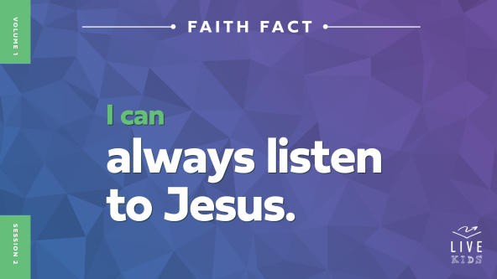

Stand up and say that with me. **I can always listen to Jesus.** Can you say it while cupping your ear like you’re trying to hear better? *(Demonstrate motion.)* **I can always listen to Jesus.** This time let’s make a funny noise in between every word. After you say a word, make a funny noise before you say the next word. **I can always listen to Jesus.** Great job!

**Game**

**Simon Says**

When we listen to Jesus, we need to pay attention. That way we won’t miss anything He says to us. I need one person tell me about a time you got lost or confused because you missed hearing something important. *(Allow response.)* Good listening really matters! Let’s practice our listening skills with a game you’ve probably played before: Simon Says. I’ll say something like, “Simon says touch your nose” or “Hop up and down.”

Only follow my instructions when I say “Simon says.” If I don’t say “Simon says,” but you do it anyway, you’re out and need to sit down. So listen carefully for what Simon says! Let’s play.

• *Here is a list of suggested actions for the game. Add “Simon says” in front of some of them.*

• Yawn

• Stand on one foot

• Shout, “Hosanna!”

• Hug yourself

• Walk backwards

• Walk on your knees

• Act like a monkey

• Wink with your left eye

• Play air guitar

• Roll over

• Waddle like a penguin

• Rub your tummy and pat your head at the same time

• Pretend to be a beautiful butterfly

• Cry like a baby

• Pretend to climb a ladder

• Wiggle your nose

• Do whatever your friend does

• Smell your feet

• Start singing

• *Play multiple rounds if you have time.*

• *Optional: Let kids lead and propose actions.*

Great job! You had to listen carefully to know what you should or shouldn’t do. It’s important to listen carefully to people, but who is it even *more* important to listen to? *(Group response)* That’s right, Jesus! That reminds me of our Faith Fact. Say it with me. **I can always listen to Jesus.**

**Worship**

Let’s listen for Jesus to speak to us as we’re worshipping Him today. Open your heart and your mind, and be ready to listen if He speaks to you through the words we sing.

• *Lead the kids in singing one or two praise songs. See suggestions at the beginning of the session.*

**Bible Lesson**

I know that Jesus loves to hear you sing to Him. Did any of you hear Jesus speak to you while we were singing? *(Group response)* If you heard Him, pay attention to what He said. It’s a good idea to write it down so you don’t forget. If you didn’t hear Him yet, keep listening!

Now let’s listen to what Jesus wants us to know from the Bible. Today we’ll find out how Nicodemus listened to Jesus and what that means for us. Let’s pray before we begin.

**Prayer**

|  |
| --- |
| *Dear Jesus, thank You for the chance to worship You. Open our heart and mind to listen to what You will say to us today through the Bible. Help us to see how we can live for You. Amen.* |

**Video Intro**

Before we look at the Bible story, let’s check in with Dash.

• *Play* ***Bible Lesson Video****.*



**Bible Story**

**Nicodemus Seeks Jesus for Answers**

Isn’t it awesome how Dash’s dad and the Holy Spirit both helped Dash understand? That really makes me want to find out more about our Bible story today! One of the things Nicodemus’s story teaches us is that we can know the truth if we listen to Jesus.

Before we dive into the Bible story, it’s important for us to know what else was happening at that time. Jesus was teaching crowds of people out in the open and performing lots of miracles. Some of the people loved Him and listened to what He said, but some didn’t. The people who knew a lot about religious rules didn’t understand who Jesus really was. They saw His power and the way people followed Him, but they didn’t see how His words fit with their ideas about God.

This might be how Nicodemus felt. He was a Pharisee and a religious leader of the Jewish people. A lot of religious leaders like him thought God would only accept them if they tried to be perfect and do the right things. They carefully followed the laws from the Old Testament plus even more rules they had made themselves. But do you think they could do it? *(Group response)* Are any of us perfect? *(Group response)* No! That’s why we need Jesus! Let’s find out what Jesus said to Nicodemus.

**Teaching Time**

Nicodemus wanted to talk with Jesus. But since he was a Pharisee, he probably was nervous about being seen with Jesus.

• *Turn off lights and use the flashlight.*

So one night after it got dark, Nicodemus found the place Jesus was staying. He asked questions about what Jesus was teaching. And Jesus spent time with Nicodemus and answered all his questions. Jesus even talked to Nicodemus about how people love the darkness, but God sent His light into the world.

• *Turn lights back on.*

Let’s read more about what Jesus said that night. Grab your Bible or pull up a Bible app on your device. Turn to [John 3:1–21](https://ref.ly/logosref/Bible.Jn3.1-21).

• *In order to keep Large Group time moving along, we recommend that the leader reads the Scripture portions aloud.*

• *Optional: Remind the kids to mark this place with a bookmark, so they can read it on their own at home.*

**1. Nicodemus looked for Jesus.**

• *Show the* ***Teaching Point 1 Slide.***

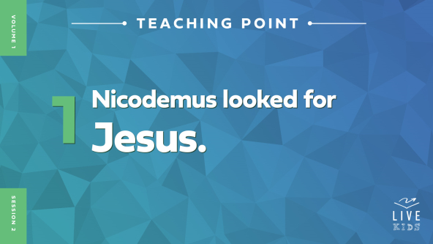

• *Read* [*John 3:1–9*](https://ref.ly/logosref/Bible.Jn3.1-9)*.*

That night, Jesus talked to Nicodemus about life that is eternal, which means it lasts forever. He explained that no one could be in God’s kingdom unless they were born again. Nicodemus was confused, because he thought Jesus meant he had to be born like a baby again! Raise your hand if you remember being a baby. *(Group response)*

• *Optional: Show your baby picture.*

Me neither! That was a long time ago. But is that what Jesus meant? *(Group response)* No, that’s not what He meant at all. Jesus was describing salvation, which is believing in Him and asking Him to forgive our sins. This change is so huge that it is like starting a brand-new life—like being born again. When I was born again, I wasn’t a baby. I was _____ years old.

• *Briefly tell about your salvation experience in just a few sentences.*

Nicodemus tried to understand what Jesus was saying, but he was having a hard time. This wasn’t like anything he had ever been taught before. He even asked Jesus how being born again was possible.

Is there anything Jesus says in the Bible that *you* have trouble understanding? *(Allow responses.)* Those are great answers! When we keep listening to Jesus, we understand more and more of His truth.

**2. Nicodemus discovered eternal life comes through Jesus.**

• *Show the* ***Teaching Point 2 Slide.***

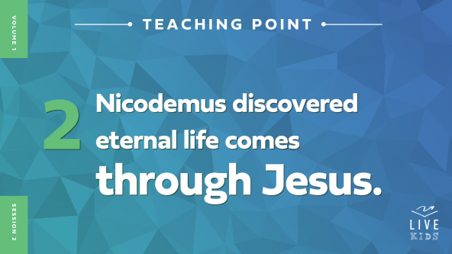

• *Read* [*John 3:10–15*](https://ref.ly/logosref/Bible.Jn3.10-15)*.*

Jesus tried to explain being born again in a way Nicodemus could understand. That way, Nicodemus could learn that eternal life only came through God’s Son—Jesus himself. Nicodemus and the other Jews knew from the Old Testament that a person called the *Messiah* was coming to save God’s people. And they had been waiting for a long time. Jesus, the One teaching and healing lots of people, was the Messiah. Nicodemus didn’t understand everything yet, but he was in the right place to find the truth. He had found Jesus! So he kept on listening.

**3. We can find eternal life through Jesus, too.**

• *Show the* ***Teaching Point 3 Slide.***

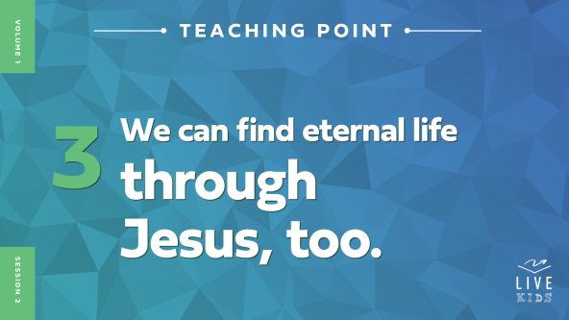

• *Read* [*John 3:16–21*](https://ref.ly/logosref/Bible.Jn3.16-21)*.*

As Nicodemus listened to Jesus, he learned about God’s love. He learned about life that lasts forever. He also learned about God’s judgment, which means punishment for sin. Nicodemus was a religious leader who was supposed to know God’s law, but he didn’t know all of God’s truth. Jesus taught him one of the most important truths in the world—without believing in Jesus, there can be no eternal life.

The great thing is that eternal life isn’t just for Nicodemus! In [John 3:16](https://ref.ly/logosref/Bible.Jn3.16), Jesus promised eternal life to everyone who believes in Him. Believing in Jesus means more than thinking He’s a good guy. It means trusting Him enough to follow Him no matter what. You see, we may know about Jesus. We may have heard His name before. We may have come to church a little or a lot. But if we don’t have our own relationship with Jesus, we’re missing out. Jesus wants us to listen to Him. Jesus wants us to learn His truth from reading the Bible. And Jesus wants us to get to know Him for ourself. If you’ve been following Jesus for a while, what is something you’ve learned about Him? *(Allow responses.)*

Jesus also wants us to shine His light so others can see it. Think about this. If someone at school had blonde hair one day and bright purple hair the next day, would you be able to tell? *(Group response)* Yes! It would be a change everyone could see. Well, everyone should be able to see when we’re living for Jesus. Our life should change so much that other people can tell we’re totally different—like we were born again!

Now, all that might sound a little complicated. How can we know Jesus for ourself if we’ve never seen Him or talked to Him? But the Bible tells us in [John 3:16](https://ref.ly/logosref/Bible.Jn3.16) that it’s simple. If we believe in Jesus, we can have eternal life, too.

**Prayer and Response**

*Consider playing a worship song softly in the background while kids pray.*

Eternal life is available for everyone here today. Just like Nicodemus, each one of us must decide on our own if we believe in Jesus. Maybe some of you have been thinking about becoming one of His followers. I’m going to give you a chance to do that now.

If you’ve never made the decision to follow Jesus by asking Him to forgive your sins, the wrong things you’ve done, don’t wait. You can be born again and start a brand-new life right now. It’s the best decision you could ever make! Let’s talk to Jesus.

**Prayer**

*Optional: Have the kids repeat phrases of the prayer after you.*

|  |
| --- |
| *Dear Jesus, thank You for loving me. I believe in You. Please forgive me for my sins. I want to be born again just like You taught Nicodemus. Please help me to live for You every day. In Your name. Amen.* |

Jesus said there is joy in heaven when we make that decision. Before you leave today, I’d like you to tell a leader if you decided to follow Jesus. Then, I want you to tell your parents or someone in your family that you will live forever because of Jesus.

**Faith Verse**

Our Faith Verse today is all about looking for Jesus and finding Him. Who remembers what *pursue* means? *(Allow responses.)* Pursuing someone means working hard to be with them. Our Faith Verse reminds us to pursue Jesus with all we have—with our whole heart. Let’s say it together and do the actions.

• *Play* ***Faith Verse Video****.*



[Jeremiah 29:13](https://ref.ly/logosref/Bible.Je29.13) (NLT)

“If you look for me wholeheartedly, you will find me.”

Let’s see who can whisper this verse the quietest—the boys or the girls. Let’s have the boys go first. Boys, whisper it all together. *(Group response)* Okay, now it’s the girls’ turn. Ready? *(Group response)* Well done, everyone!

**Faith Fact**

If we pursue Jesus wholeheartedly, we’ll find Him. And when we find Him, He will speak to us. Our Faith Fact tells us what to do when He speaks. **I can always listen to Jesus.**

• *Show the* ***Faith Fact Slide****.*



Say it with me before we go to our small groups. **I can always listen to Jesus.** Great job! I’ve had so much fun diving into Nicodemus’s story today with you. I can’t wait to listen for more of Jesus’ truth.

• *Dismiss kids to Small Group time or to go home if your group time ends here.*

**Small Group**

**30 Minutes**

*This section can be done in conjunction with the large group or on its own if you do small groups with your kids. During Small Group time, the goal is to connect the kids with the Word of God and to each other. All activities are led by the small group leader.*

**Group Connection**

**One-Word Story**

|  |
| --- |
| ***You Will Need***  *• Inflated balloons, one per group*  ***Getting Ready***  *• Blow up the balloon(s). Don’t use helium.* |

We’re going to tell a story together. You’ll have to listen carefully, or the story will get crazy!

• *Optional: Have kids tell a story about what they think Nicodemus did after he met with Jesus.*

I’m going to start our story, but I’ll only say one word. Then I’ll pass the balloon to the next person, who will add just one word to our story. Each person can say only one word. And you can only speak if you’re holding the balloon. The rest of the time, we all need to listen. We’ll keep going until the story feels like it’s finished. Then we’ll all say, “The end.”

• *Continue the story as time allows.*

That was very creative storytelling—and good listening, too!

**Bible Lesson Recap**

• *If small group activities are not immediately following large group time, you may want to read the Bible story passage before the discussion.*

|  |
| --- |
| ***You Will Need***  *• Bibles for kids in the group to share*  *No prep needed for this activity.* |

**Bible Story Review: Nicodemus Seeks Jesus for Answers** [**John 3:1–21**](https://ref.ly/logosref/Bible.Jn3.1-21)

Today our Bible story was about Nicodemus. What do you remember about him? *(Allow responses.)* Great memory! He was a Jewish religious leader. He thought God would only accept him if he followed certain rules. But he was curious about Jesus. He wanted to talk to Jesus, but he probably didn’t want to get caught doing it. So Nicodemus searched for Jesus one night—and found Him.

Nicodemus was confused by the truth Jesus told him. Jesus said the only way to be part of God’s kingdom is by believing in Him. Jesus also said people who believe in Him are born again—meaning we have a brand-new life.

• *Give each kid a Bible and read the Bible story together.*

**Group Discussion**

*Feel free to use all or just a few questions as a jumping-off place for good discussion. Questions marked with * are designed for more conversation. Adjust the questions based on the age or maturity of your group. Typically, older kids will be able to dive a little deeper than younger ones.*

**Questions**

Who did Nicodemus lead?

* What do you imagine Nicodemus was like before he talked with Jesus?

Why did Nicodemus probably have to go to and talk with Jesus in the night?

* If you were Nicodemus, what questions would you ask Jesus?

Do you think Nicodemus believed Jesus when He said that the way to eternal life was by believing in Him? Why or why not?

Are you ever scared about what other people will think if they know you love Jesus? If so, when?

* What are some ways we can listen to Jesus?

* How can we show others that our life is different because we know and listen to Jesus?

**Live It**

**Faith Fact**

Nicodemus listened to Jesus and learned about eternal life. That reminds me of our Faith Fact: **I can always listen to Jesus.** Say it with me: **I can always listen to Jesus.** Have any of you ever heard Jesus speak to you? *(Group response)* What did you hear Him say? *(Allow responses.)* Listening for Jesus to speak to you takes time and practice. So we have just one simple challenge today.

**Challenge**

We’re going to practice listening. Take time every day this week to pray and ask Jesus to speak to you. Then just sit quietly and listen. He might say something to you in your mind. Or you might feel Him nudge you to do something or stop doing something. The more you practice listening for Jesus’ voice and doing what He asks, the easier it will become to hear Him speak to you.

**Prayer**

*Finish group discussion by sharing prayer requests and praise reports. Keep track of your small group’s prayer requests and review them each time you meet.*

• *Have kids share and pray for each other’s prayer requests.*

|  |
| --- |
| *Dear Jesus, thank You for loving us so much. You came to earth to die for our sins so we could follow You and live forever. Please help us shine Your light so other people can believe in You too. Amen.* |

**Faith Verse Review**

|  |
| --- |
| ***You Will Need***  *•* ***Small Group Faith Verse Review****, one set per team*  *• Cups, one per team*  *• Smartphone or timer*  ***Getting Ready***  *• Print and cut apart the* ***Small Group Faith Verse Review****, one set per team.*  *• Place each set of slips in a cup, one set per team.* |

Our Faith Verse is [Jeremiah 29:13](https://ref.ly/logosref/Bible.Je29.13). In our Bible story, Nicodemus looked for Jesus and found Him. We can too! Let’s review the Faith Verse now.

• *Show* ***Faith Verse Video****.*



[Jeremiah 29:13](https://ref.ly/logosref/Bible.Je29.13) (NLT)

“If you look for me wholeheartedly, you will find me.”

**Faith Verse Fun**

**Scripture Scramble**

Our Faith Verse is a great one to remember. Let’s practice unscrambling it together. Pay attention, because after we practice together, we’ll divide into teams and have a race!

• *Use one set of the* ***Faith Verse Review*** *slips for the practice round. Put the verse together as a group.*

• *Divide into teams. Give each team a set of the* ***Faith Verse Review*** *slips. Have the teams unscramble the verse. Time the teams. Record the fastest times, and declare a winner.*

**Activity Page**

**Secret Code**

|  |
| --- |
| ***You Will Need***  *•* ***Small Group Activity Page****, one per kid*  ***Getting Ready***  *• Print copies of the* ***Small Group Activity Page****, one per kid.* |

Nicodemus wanted to meet with Jesus, but he probably didn’t want other people to see him. So Nicodemus met Jesus secretly at night. While they were talking, Jesus told Nicodemus some very important truths. Use the secret code to figure out one thing Jesus shared with him.

• *Give each kid a copy of the* ***Small Group Activity Page*** *and a pencil, and let them decipher the message.*

Did you figure out what Jesus said? *(Group response)* God loves us so much. He sent Jesus to this world to die for our sins. And then Jesus came back to life! Because of Jesus, we can be born again and live forever with Him.

**Dismissal**

I hope you know how important you are! Jesus himself wants to spend forever with you. Let’s pray.

**Prayer**

|  |
| --- |
| *Dear Jesus, thank You for our time together today. Thank You for showing us through Nicodemus’s story just how important each one of us is to You. You love us so much that You want us to have eternal life—and we are so thankful! We love You. Amen.* |

**Faith Fact Recap**

• *Show the* ***Faith Fact Slide****.*



When Nicodemus listened to Jesus, he found out about eternal life. Jesus wants us to listen to Him, too. One more time, let’s say our Faith Fact together. Ready? **I can always listen to Jesus.** I’m so glad you came today. I can’t wait to see you next time!

• *Send home the* ***Small Group Activity Page.***

• *Remind parents that there are* ***Family Devotions*** *available on the app to do with their kid.*

• *Tell everyone the date and time for the next session.*

***Note to leader:*** *Be sure to order the disappearing paper for the next session’s Teaching Time (Session 1.3).*